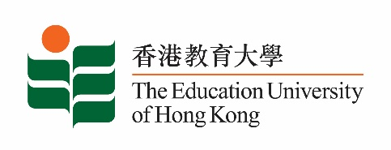

5 September 2025

**致：**  **传媒机构采访主任**

**To : News Editors**

**香港教育大学（教大）2025年9月8日至21日可供采访之活动一览**

**The Education University of Hong Kong (EdUHK) Events Calendar for 8-21 September 2025**

本校诚邀　贵机构派员采访下列活动。传媒查询，请联络教大传讯处（电话：2948 6050）。  
You are cordially invited to cover the events below. For media enquiries, please contact the Communications Office at 2948 6050.

以下活动或有人数限制，传媒请预先向主办部门登记。

There may be restrictions on the number of participants for the following event(s). Please contact the respective organiser(s) / department(s) for prior registration.

* **教大大埔校园**（新界大埔露屏路十号）

**EdUHK Tai Po Campus** (10 Lo Ping Road, Tai Po, New Territories)

|  |  |  |  |  |  |
| --- | --- | --- | --- | --- | --- |
| **日期**  **Date** | **时间**  **Time** | **活动**  **Event** | **地点**  **Venue** | **主办部门及公众查询**  **Organiser &**  **Public Enquiry** | **备注**  **Remarks** |
| 2025-09-13 to 2025-09-14 | 0900-1800 | 一带一路艺术与文化国际研讨会  International Conference on One Belt One Road Arts and Culture 2025 | 香港故宫文化博物馆  Hong Kong Palace Museum | 文化与创意艺术学系  Department of Cultural and Creative Arts  查询/ Enquiries:  梁博士/ Dr Leung  icoac25@eduhk.hk  电话/ Tel: 2948 7168 |  |